[Course](https://lms.codinginvaders.com/courses/course-v1:CodingInvaders+DATEST+1/course/) [Power BI Module 3](https://lms.codinginvaders.com/courses/course-v1:CodingInvaders+DATEST+1/course/#block-v1:CodingInvaders+DATEST+1+type@chapter+block@3f21980184bf4ce78c467aa9302d4187) [Introduction](https://lms.codinginvaders.com/courses/course-v1:CodingInvaders+DATEST+1/course/#block-v1:CodingInvaders+DATEST+1+type@sequential+block@f50fb764709e4b16b3bfe8a3dbac42e1) Structure

## **Structure**

Bookmark this page

**Structure**

**Part 1: Modeling and Optimization**

**Quick Intro**

* + What is STAR Schema?
  + Why do we need Schema?
  + What are fact and dimension?
  + How Schema on Power BI can improve performance

**Organizing the flat file**

* + Difference between fact and fact less tables
  + Creating fact and dimension relationship
  + Model optimization

**Part 2: Customisations**

**Introduction**

* + Customizations Options
  + New Visuals
  + Custom Themes
  + Format Visuals

**Part 3: Interactions**

**Introductions**

* + Edit Interactions
  + Bookmarks
  + Selection (Layer Order)
  + Sync Slicer
  + Tips and tricks
  + Mobile Layout

**Part 4: Introduction to DAX**

**Overview of DAX**

* + Why DAX?
  + Importance of DAX and difference between DAX and m query
  + When to use DAX?

**Sample function and structure**

* + How to write a DAX (we will use measures)
  + Parts in DAX Function
  + How to use DAX?
  + Types of DAX functions

**Simple DAX Tables**

* + What are DAX tables
  + How it is different from m table
  + How to write a DAX function

**Part 5: Capstone project**

[Course](https://lms.codinginvaders.com/courses/course-v1:CodingInvaders+DATEST+1/course/) [Power BI Module 3](https://lms.codinginvaders.com/courses/course-v1:CodingInvaders+DATEST+1/course/#block-v1:CodingInvaders+DATEST+1+type@chapter+block@3f21980184bf4ce78c467aa9302d4187) [Introduction](https://lms.codinginvaders.com/courses/course-v1:CodingInvaders+DATEST+1/course/#block-v1:CodingInvaders+DATEST+1+type@sequential+block@f50fb764709e4b16b3bfe8a3dbac42e1) Dataset Explaination

## **Dataset Explaination**

Bookmark this page

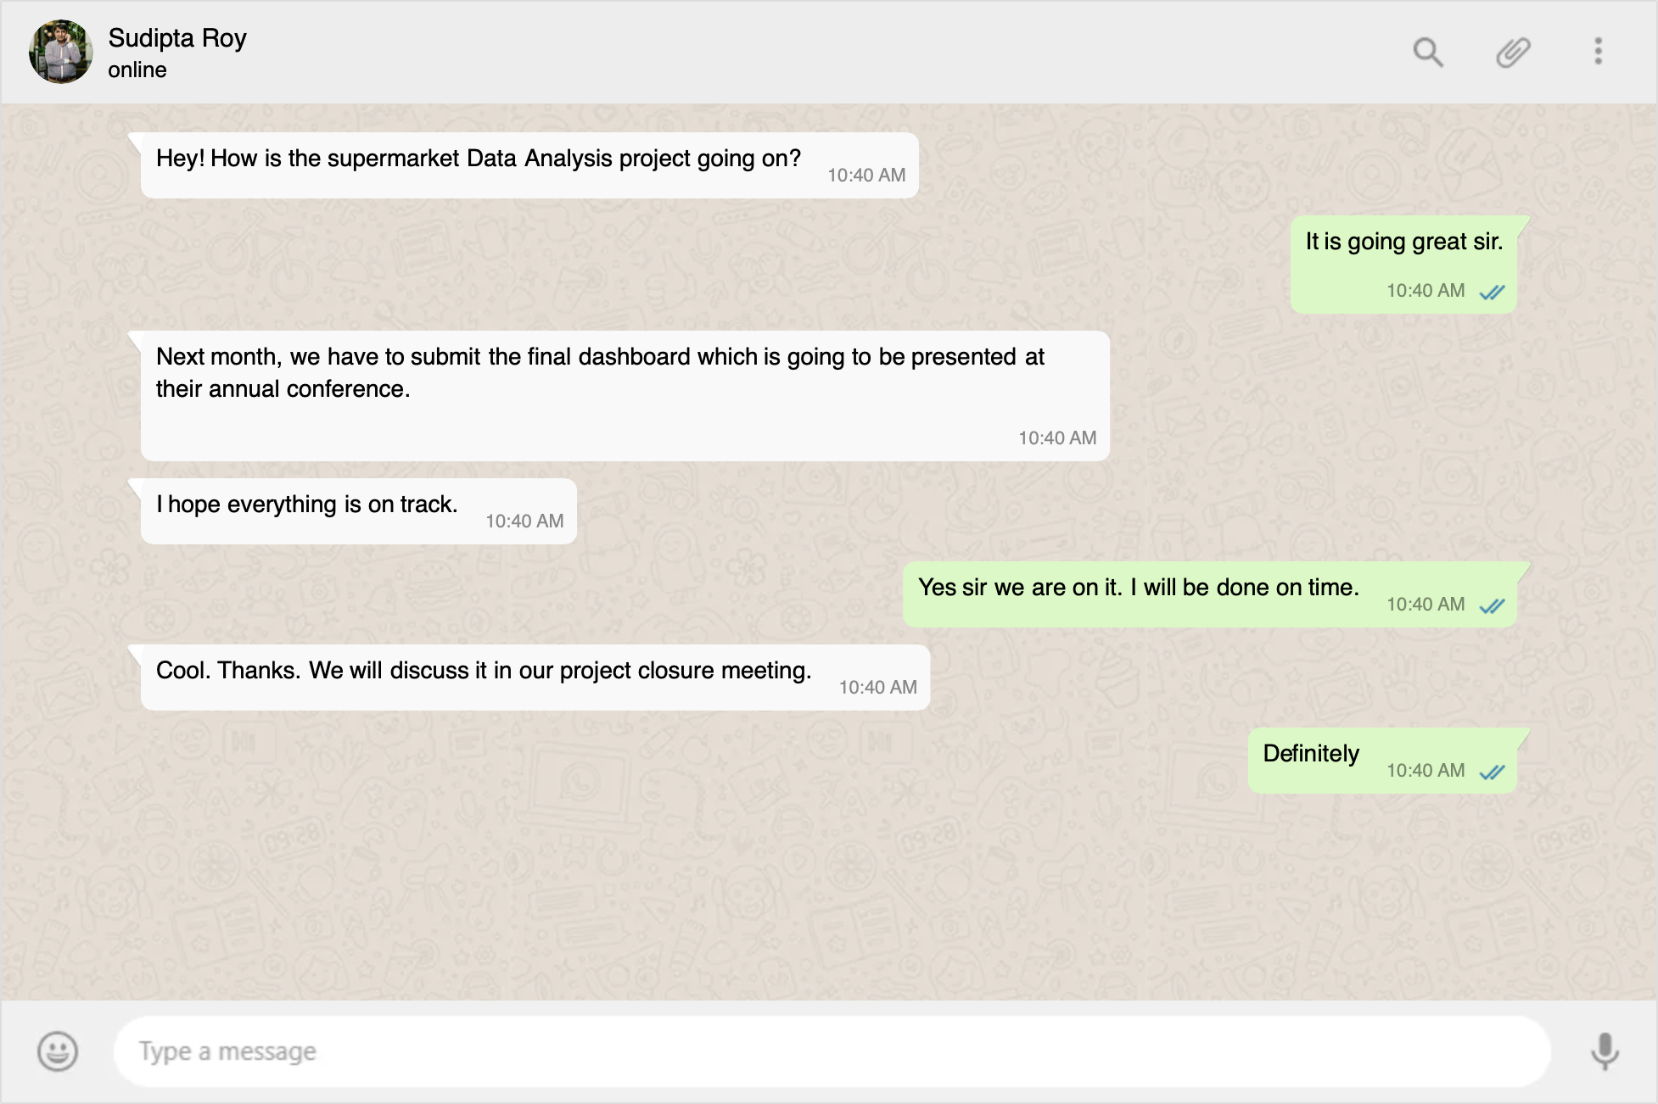

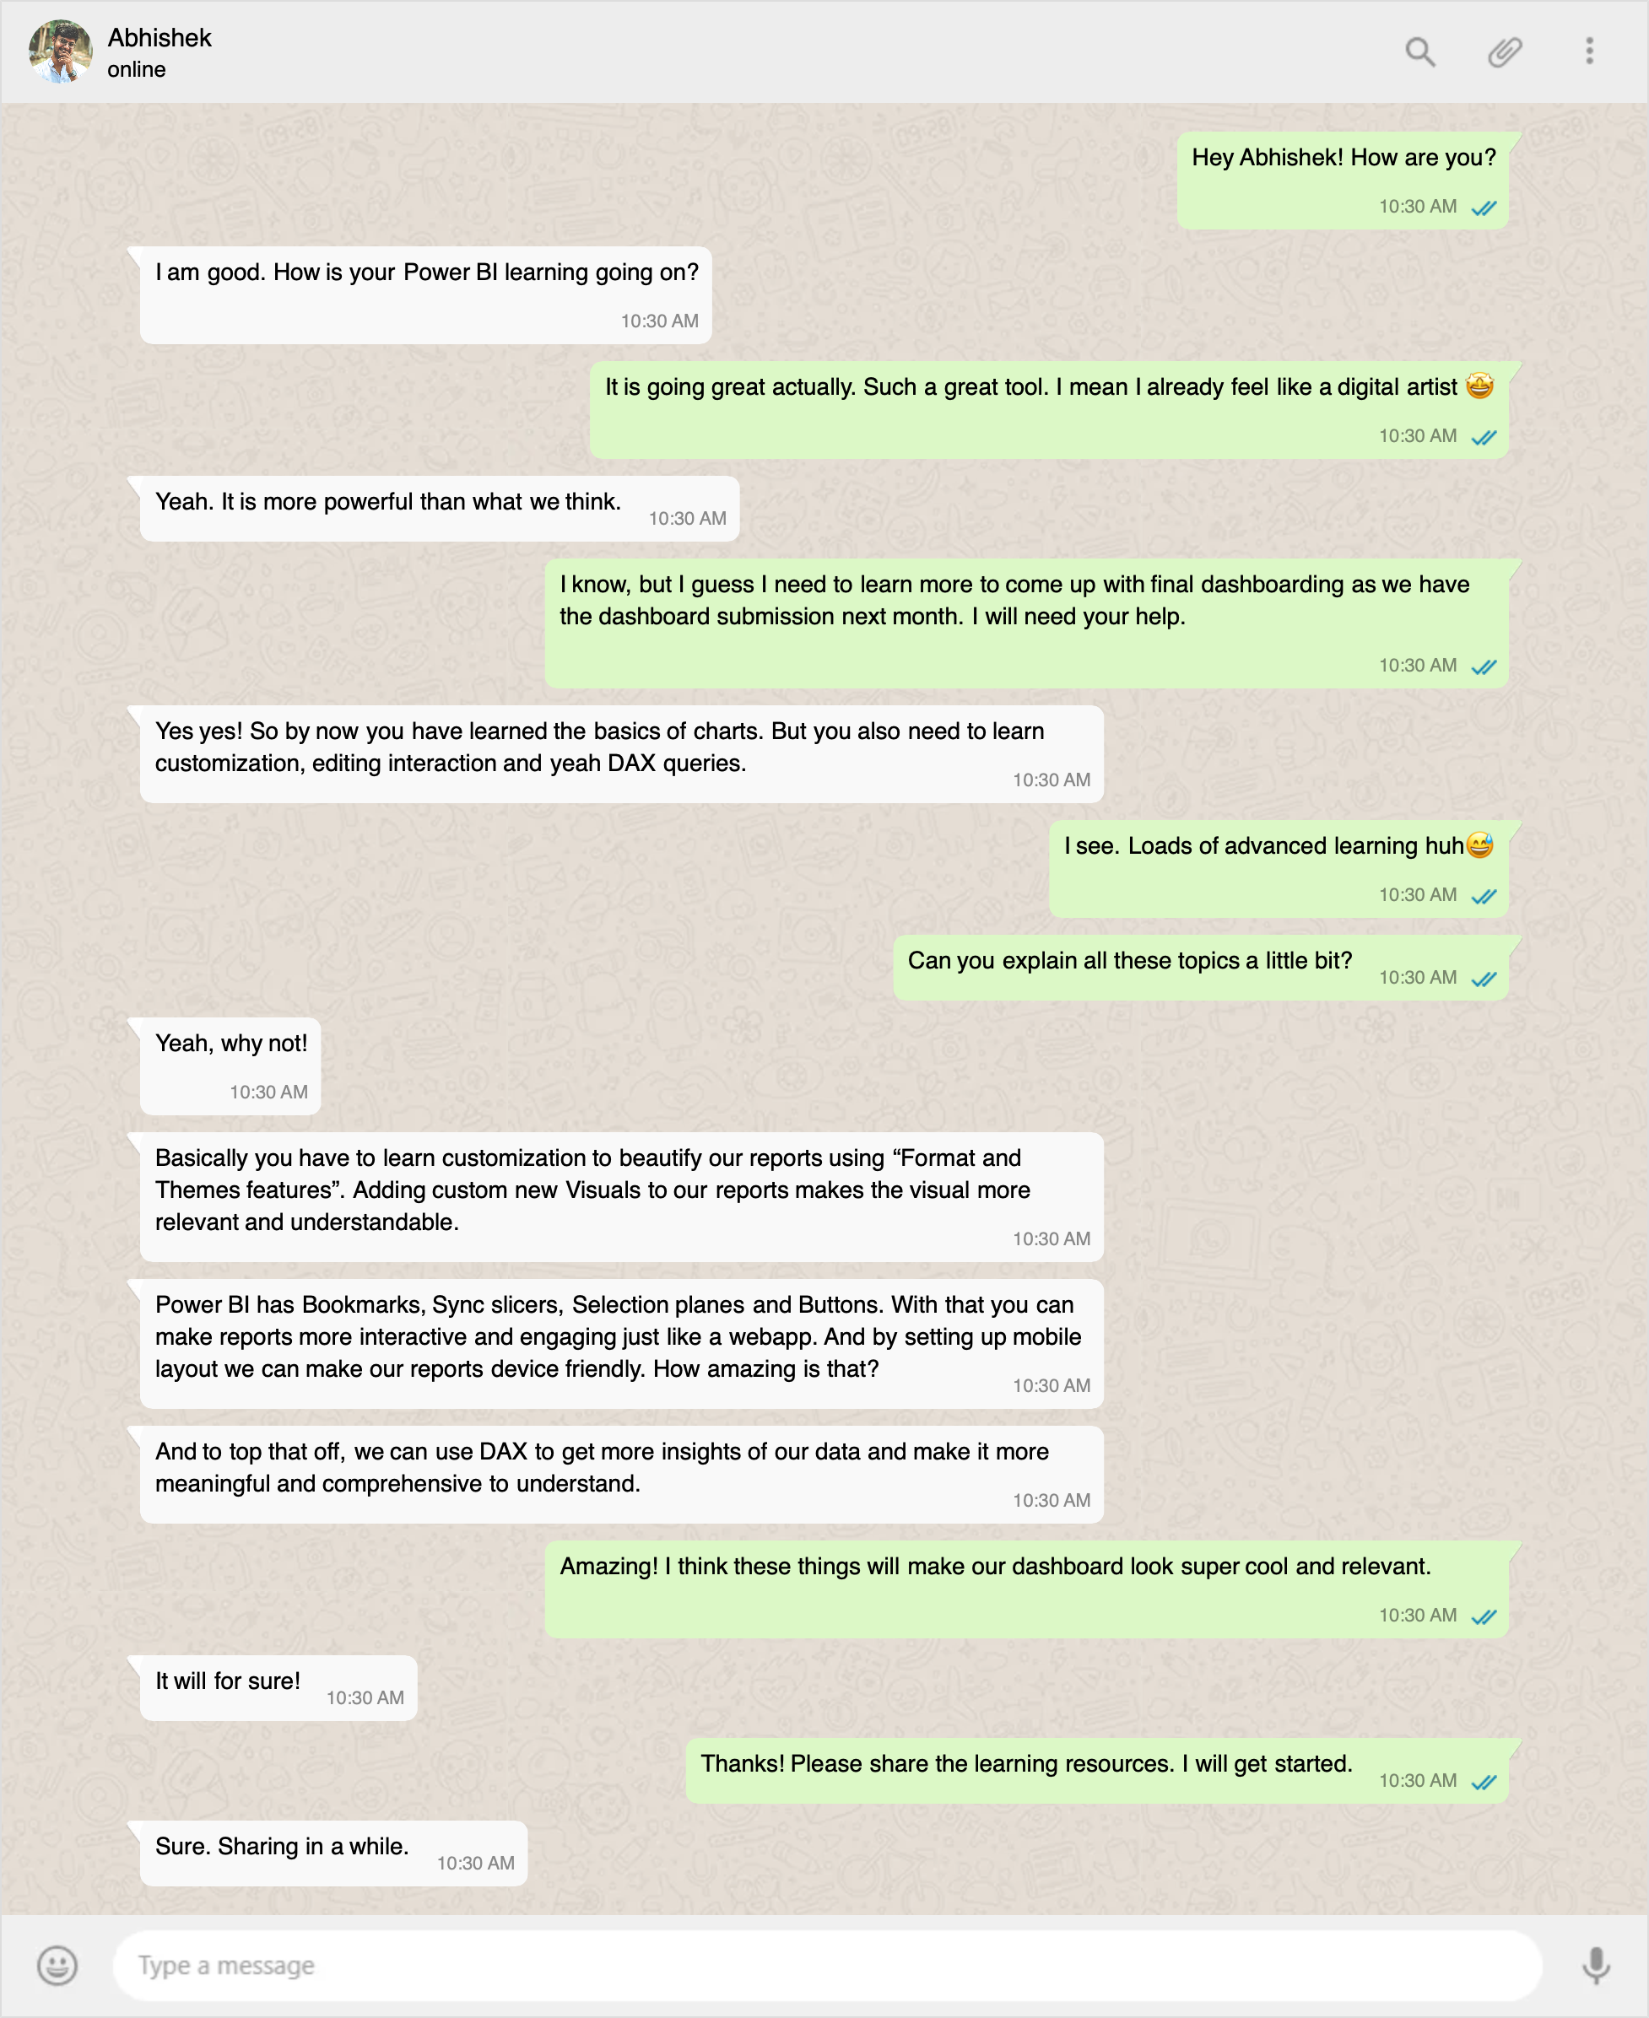

#### **Demo Dataset**

A sales dataset for Superstore consisting of order, product, and customer details.

Download the dataset here: [**Demo Superstore Data**](https://lms.codinginvaders.com/assets/courseware/v1/c57ac0f20f22ab21d29abf82c7fa35bc/asset-v1:CodingInvaders+DATEST+1+type@asset+block/Demo_Superstore_data.xlsm)

**Table Description**

| **Sl.No** | **Column Name** | **Column Description** |
| --- | --- | --- |
| 1 | Order ID | Unique Identifier For the Order |
| 2 | Order Date | Date of the order places |
| 3 | Ship Date | Date of the order shipped |
| 4 | Ship Mode | Priority Mode of Shipping ( Same Day, First Class, Second Class, Standard Class ) |
| 5 | Customer ID | Customer Unique Identifier |
| 6 | Customer Name | Name of the customer |
| 7 | Segment | Customer Segment ( Consumer, Corporate, Home Office ) |
| 8 | Country | Name of the Country |
| 9 | City | Name of the City |
| 10 | State | Name of the State |
| 11 | Postal Code | Postal Code |
| 12 | Region | Name of the Region |
| 13 | Product ID | Unique Product Identifier |
| 14 | Category | Product Category |
| 15 | Sub-Category | Product Sub - Category |
| 16 | Product Name | Name of the Product |
| 17 | Sales | Total Sale Amount |
| 18 | Quantity | Quantity of the product ordered |
| 19 | Discount | Discount % on the product |
| 20 | Profit | Profit earned on the product sale |

**Demo dataset Sample**

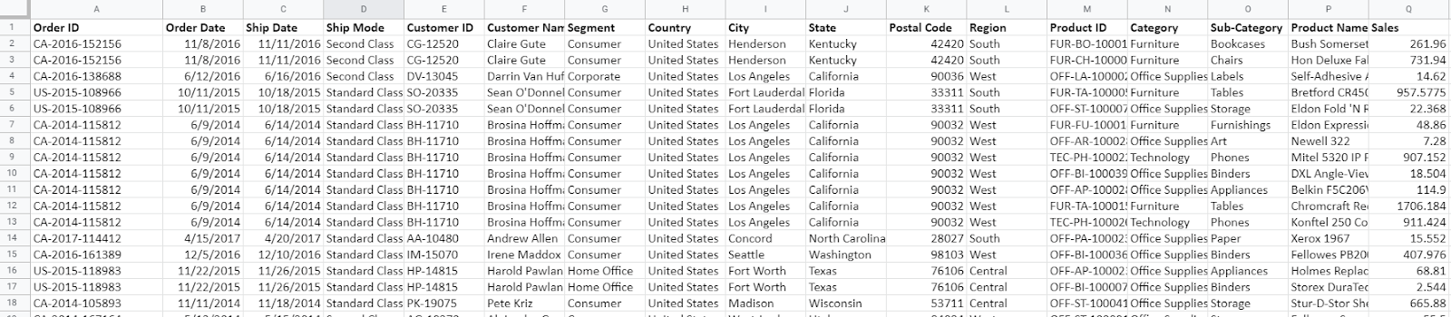

#### **Guided Dataset**

A sales dataset for Superstore consisting of order, product, and customer details with a range of columns as below.

Download the dataset here: [**Superstore Dataset**](https://lms.codinginvaders.com/assets/courseware/v1/31c3a9d47ec901b6243263916b7d2754/asset-v1:CodingInvaders+DATEST+1+type@asset+block/Guided_Superstore_Sales_dataset2011-2015.xlsx)

**Table Description**

| **Sl No.** | **Column Name** | **Column Description** |
| --- | --- | --- |
| 1 | Order ID | Unique Identifier For the Order |
| 2 | Order Date | Date of the order places |
| 3 | Ship Date | Date of the order shipped |
| 4 | Ship Mode | Priority Mode of Shipping ( Same Day, First Class, Second Class, Standard Class ) |
| 5 | Customer ID | Customer Unique Identifier |
| 6 | Customer Name | Name of the customer |
| 7 | Segment | Customer Segment ( Consumer, Corporate, Home Office ) |
| 8 | City | Name of the City |
| 9 | State | Name of the State |
| 10 | Country | Name of the Country |
| 11 | Postal Code | Postal Code |
| 12 | Market | Continental Zones |
| 13 | Region | Name of the Region |
| 14 | Product ID | Unique Product Identifier |
| 15 | Category | Product Category |
| 16 | Sub-Category | Product Sub - Category |
| 17 | Product Name | Name of the Product |
| 18 | Sales | Total Sale Amount |
| 19 | Quantity | Quantity of the product ordered |
| 20 | Discount | Discount % on the product |
| 21 | Profit | Profit earned on the product sale |
| 22 | Shipping Cost | Cost of Shipping |
| 23 | Order Priority | Priority Level of order ( Medium, High, Critical ) |